SWT 22022 – Practical for Internet Application Development
Department of Information and Communication Technology
Faculty of Technology
Lab sheet :05
Reg. Number: SEU/IS/20/ICT/084
Academic Year :2020/2021
Date: 2024.06.24
Practical No :05

Title: PHP Session and Cookies.
Aims:
• Understand and implement PHP sessions and cookies.
• Managing user data and preferences.
Tasks:
• Managing User Sessions.
• User Authentication with sessions.
• Cookies in PHP.
• Working with Cookies in PHP

Activities :

- Managing User Sessions

<?php
// start a session
session_start();

// create session variable
$_SESSION['username'] = "Olivia123";

// unset specific session variable data
unset($_SESSION['username']);

// unset the all the session variables data
session_unset();

// stop the session running
session_destroy();

?>

<?php
session_start();
$_SESSION['username'] = "Kalhara";
$_SESSION['index_no']="SEU/IS/20/ICT/084";
$_SESSION['password']="#4535fdDED";

?>

<!DOCTYPE html>
<html lang="en">
<head>
<meta charset="UTF-8">
<meta name="viewport" content="width=device-width, initial-scale=1.0">
<title>Document</title>
</head>
<body>

<?php echo $_SESSION['username']; ?>
<br>
<?php echo $_SESSION['index_no']; ?>
<br>
<?php echo $_SESSION['password']; ?>

</body>
</html>
<?php
unset($_SESSION['username']);
unset($_SESSION['index_no']);
unset($_SESSION['password']);
session_unset();
session_destroy();
?>

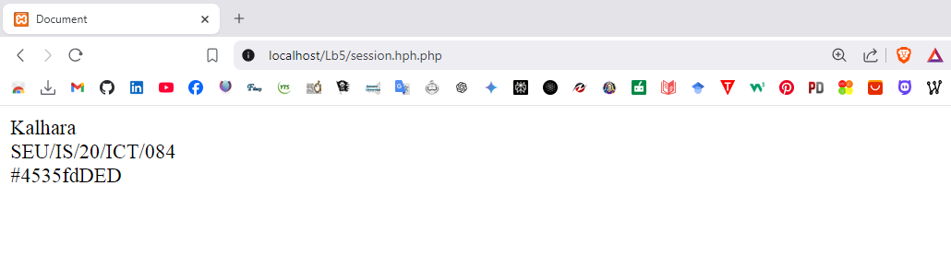

2. User Authentication with sessions.
I. Create a new PHP file named login.php.
II. Implement login form and php script for store session.

<?php
session_start();
$username = "Olivia123";
$password = "Oli123#$2";
if (isset($_POST['username']) && isset($_POST['password'])) {
$entered_username = $_POST['username'];
$entered_password $_POST['password'];
if ($entered_username === $username && $entered_password ===$password){

$_SESSION['username'] = $username;
header("Location: profile.php"); exit;
}
else {
$error_message = "Invalid username or password.";
}
}
?>

login.php
<?php
session_start();
$username = "Kalhara";
$password = "Pasa2001#";

if (isset($_POST['username']) && isset($_POST['password'])) {
$entered_username = $_POST['username'];
$entered_password = $_POST['password'];

if ($entered_username === $username && $entered_password === $password) {
$_SESSION['username'] = $username;
header("Location: profile.php");
exit;
} else {
$error_message = "Invalid username or password.";
}
}
?>

<!DOCTYPE html>
<html>
<head>
<title>Login Page</title>
<link rel="stylesheet" href="https://cdn.jsdelivr.net/npm/bootstrap@5.3.2/dist/css/bootstrap.min.css">

</head>
<body>
<div class="container">
<div
class="row justify-content-center">
<div class="col-md-6">
<h2>Login</h2>

<?php if (isset($error_message)) { ?>
<div class="alert alert-danger" role="alert">
<?php echo $error_message; ?>
</div>
<?php } ?>

<form action="<?php echo $_SERVER['PHP_SELF']; ?>" method="post">
<div class="mb-3">

<label for="username" class="form-label">Username:</label>
<input type="text" class="form-control" id="username" name="username">
</div>

<div class="mb-3">
<label for="password" class="form-label">Password:</label>
<input type="password" class="form-control" id="password" name="password">
</div>

<button type="submit" class="btn btn-primary">Login</button>

</form>
</div>
</div>
</div>
<script src="https://cdn.jsdelivr.net/npm/bootstrap@5.3.2/dist/js/bootstrap.bundle.min.js"></script>
</body>
</html>

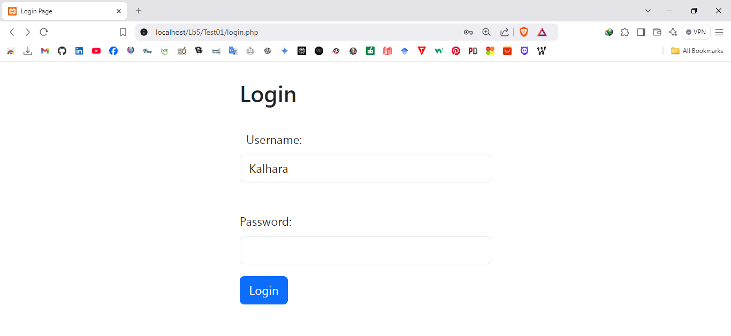
III. Create a new PHP file named profile.php
IV. Display the name within body tag.

<?php

session_start();
if (!isset($_SESSION['username'])) {

header("Location: login.php");
exit;
}
?>

profile.php

<?php
session_start();
if (!isset($_SESSION['username'])) {
header("Location: login.php");
exit;
}
?>

<!DOCTYPE html>
<html>
<head>
<title>Profile Page</title>
<link rel="stylesheet" href="https://cdn.jsdelivr.net/npm/bootstrap@5.3.2/dist/css/bootstrap.min.css">
</head>
<body>
<div class="container">
<div class="row justify-content-center">
<div class="col-md-6">
<h2>Welcome to Your Profile, <?php echo htmlspecialchars($_SESSION['username']); ?>!</h2>
<p>This is your secure profile page.</p>
<a href="logout.php" class="btn btn-danger">Logout</a>
</div>
</div>
</div>
<script src="https://cdn.jsdelivr.net/npm/bootstrap@5.3.2/dist/js/bootstrap.bundle.min.js"></script>
</body>
</html>

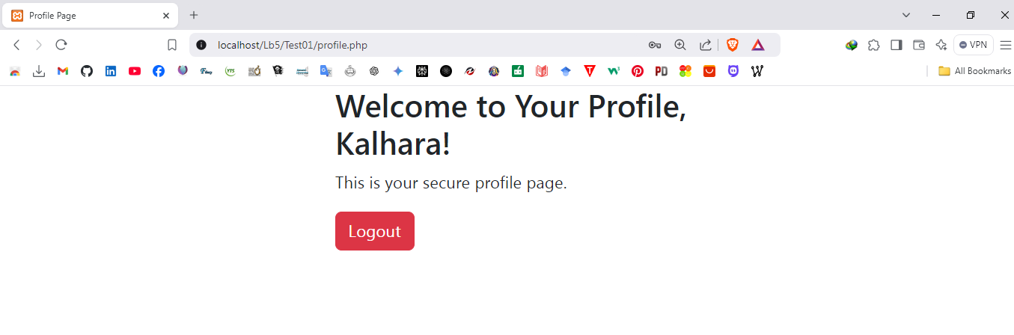

V. Create a new PHP file named logout.php
VI. Implement PHP script to logout from the page.

<?php
session_start();
session_destroy();
header("Location: login.php");
exit;
?>

logout.php

<?php
session_start();
session_destroy();
?>

<!DOCTYPE html>
<html>
<head>
<title>Logout</title>
<link rel="stylesheet" href="https://cdn.jsdelivr.net/npm/bootstrap@5.3.2/dist/css/bootstrap.min.css">
</head>
<body>
<div class="container">
<div class="row justify-content-center">
<div class="col-md-6 text-center">
<h2>You have been logged out.</h2>
<p>Thank you for visiting. Click below to log in again.</p>
<a href="login.php" class="btn btn-primary">Go to Login</a>
</div>
</div>
</div>
<script src="https://cdn.jsdelivr.net/npm/bootstrap@5.3.2/dist/js/bootstrap.bundle.min.js"></script>
</body>
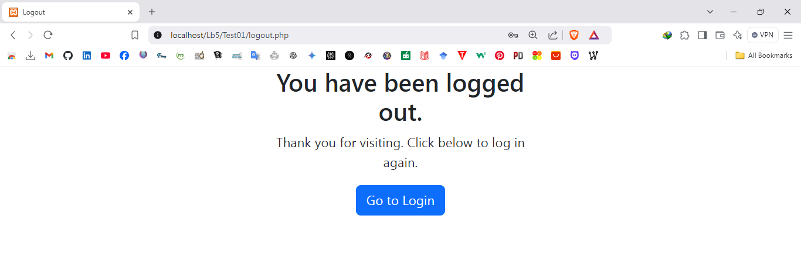
</html>

3.Cookies in PHP

<?php
// set cookies
setcookie("language", "English", time() + (86400 * 5), "/");
// access cookies
$language = $_COOKIE['language'];
?>

cookies.php
<!DOCTYPE html>
<html>
<head>
<title>Language Preference</title>
<link rel="stylesheet" href="https://cdn.jsdelivr.net/npm/bootstrap@5.3.2/dist/css/bootstrap.min.css">
</head>
<body>
<div class="container mt-5">
<div class="row justify-content-center">
<div class="col-md-6 text-center">
<h2>Set Language Preference</h2>

<?php
$cookie_name = "language";
$cookie_value = "English";
$cookie_expiration = time() + (86400 * 5);
setcookie($cookie_name, $cookie_value, $cookie_expiration, "/");

if ($_SERVER['REQUEST_METHOD'] === 'POST') {
if (isset($_COOKIE[$cookie_name])) {
$language = $_COOKIE[$cookie_name];
echo "<p>Preferred language: " . htmlspecialchars($language) . "</p>";
} else {
echo "<p>Preferred language is not set.</p>";
}
} else {
echo "<form method='POST'><button type='submit' class='btn btn-primary'>Show Preferred Language</button></form>";
}
?>
</div>
</div>
</div>
<script src="https://cdn.jsdelivr.net/npm/bootstrap@5.3.2/dist/js/bootstrap.bundle.min.js"></script>
</body>
</html>

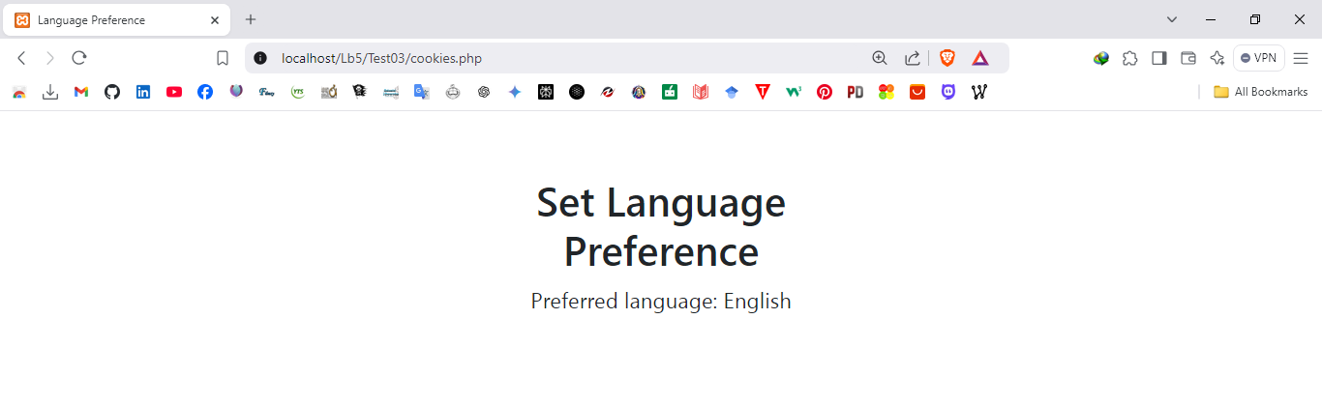

4. Working with cookies
I. Create a PHP file named preferred_color.php
II. Implement functionality to remember your preferred color as cookies

<?php
if (isset($_GET["color_scheme"])) {
$new_scheme = $_GET["color_scheme"];
if ($new_scheme === "light" || $new_scheme === "dark") {
setcookie("color_scheme", $new_scheme, time() + 3600 * 24 * 7);
header("Location: preferred_color.php");
}
}
$color_scheme = $_COOKIE["color_scheme"];
if ($color_scheme === "light") {
$body_style = "background-color: #fff; color: #000;";
} else {
$body_style = "background-color: #373A40; color: #fff;";
}
?>

preferred_color.php
<?php
if (isset($_GET["color_scheme"])) {
$new_scheme = $_GET["color_scheme"];
if ($new_scheme === "light" || $new_scheme === "dark") {
setcookie("color_scheme", $new_scheme, time() + 3600 * 24 * 7, "/");
header("Location: preferred_color.php");
exit;
}
}
$color_scheme = isset($_COOKIE["color_scheme"]) ? $_COOKIE["color_scheme"] : "light";
if ($color_scheme === "light") {
$body_style = "background-color: #fff; color: #000;";
} else {
$body_style = "background-color: #373A40; color: #fff;";
}
?>

<!DOCTYPE html>
<html>
<head>
<title>Preferred Color Scheme</title>
<link rel="stylesheet" href="https://cdn.jsdelivr.net/npm/bootstrap@5.3.2/dist/css/bootstrap.min.css">
</head>
<body style="<?php echo $body_style; ?>">
<div class="container mt-5">
<div class="row justify-content-center">
<div class="col-md-6 text-center">
<h2>Select Your Color Scheme</h2>
<a href="?color_scheme=light" class="btn btn-light">Light Mode</a>
<a href="?color_scheme=dark" class="btn btn-dark">Dark Mode</a>
<hr>
<p>Your current color scheme is: <strong><?php echo htmlspecialchars($color_scheme); ?></strong></p>
</div>
</div>
</div>
<script src="https://cdn.jsdelivr.net/npm/bootstrap@5.3.2/dist/js/bootstrap.bundle.min.js"></script>
</body>
</html>

Discussion:
- In this lab practical session, I focused on understanding and implementing PHP sessions and cookies, two essential components for managing user data and preferences in web applications. I began by exploring how to manage user sessions effectively, learning how sessions can store user-specific information across multiple pages, enhancing the user experience. The practical aspect involved creating a user authentication system using sessions, allowing users to log in and maintain their authentication status while navigating the site. Additionally, I delved into the role of cookies in PHP, examining how they can store small pieces of data on the client side, such as user preferences and settings. I also practiced working with cookies, implementing functionality to set, retrieve, and delete them. This hands-on experience solidified my understanding of session management and cookie handling in PHP, crucial for developing dynamic and user-friendly web applications.

